# Exercises: Entity Relations

This document defines the **exercise assignments** for the ["Databases Advanced – EF Core" course @ Software University](https://softuni.bg/trainings/3221/entity-framework-core-february-2021).

## Student System

Your task is to create a database for the **Student System**, using the **EF Core Code First** approach. It should look like this:

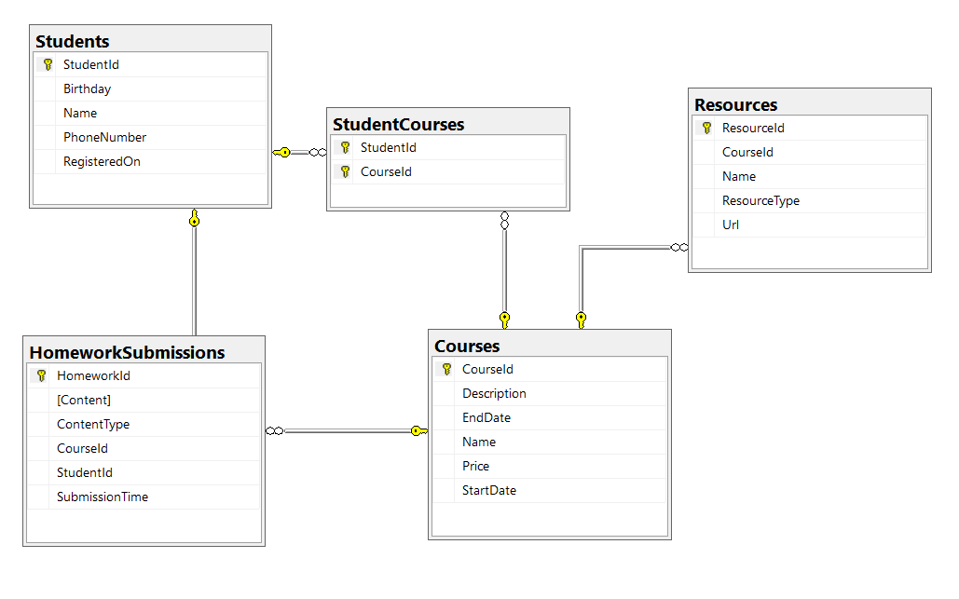

### Constraints

Your **namespaces** should be:

* ~~P01_StudentSystem – for your Startup class, if you have one~~
* ~~P01_StudentSystem.Data – for your DbContext~~
* ~~P01_StudentSystem.Data.Models – for your models~~

Your **models** should be:

* ~~StudentSystemContext – your DbContext~~
* Student:
  + ~~StudentId~~
  + ~~Name (up to 100 characters, unicode)~~
  + ~~PhoneNumber (exactly 10 characters, not unicode, not required)~~
  + ~~RegisteredOn~~
  + ~~Birthday (not required)~~
* Course:
  + ~~CourseId~~
  + ~~Name (up to 80 characters, unicode)~~
  + ~~Description (unicode, not required)~~
  + ~~StartDate~~
  + ~~EndDate~~
  + ~~Price~~
* Resource:
  + ~~ResourceId~~
  + ~~Name (up to 50 characters, unicode)~~
  + ~~Url (not unicode)~~
  + ~~ResourceType (enum – can be Video, Presentation, Document or Other)~~
  + ~~CourseId~~
* Homework:
  + ~~HomeworkId~~
  + ~~Content (string, linking to a file, not unicode)~~
  + ~~ContentType (enum – can be Application, Pdf or Zip)~~
  + ~~SubmissionTime~~
  + ~~StudentId~~
  + ~~CourseId~~
* ~~StudentCourse – mapping class between~~ **~~Students~~** ~~and~~ **~~Courses~~**

Table relations:

* **~~One student~~** ~~can have~~ **~~many CourseEnrollments~~**
* **~~One student~~** ~~can~~~~have~~ **~~many HomeworkSubmissions~~**
* **~~One course~~** ~~can have~~ **~~many StudentsEnrolled~~**
* **~~One course~~** ~~can have~~ **~~many Resources~~**
* **~~One course~~** ~~can have~~ **~~many HomeworkSubmissions~~**

You will need a constructor, accepting **DbContextOptions** to test your solution in **Judge**!

## Football Betting

Your task is to create a database for a **Football Bookmaker System**, using the **Code First** approach. It should look like this:

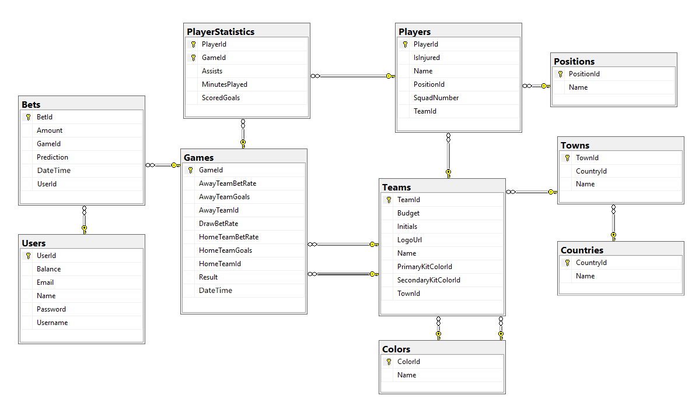

### Constraints

Your **namespaces** should be:

* P03_FootballBetting – for your Startup class, if you have one
* P03_FootballBetting.Data – for your DbContext
* P03_FootballBetting.Data.Models – for your models

Your models should be:

* **~~FootballBettingContext~~** ~~– your DbContext~~
* **~~Team~~** ~~– TeamId, Name, LogoUrl, Initials (JUV, LIV, ARS…), Budget, PrimaryKitColorId, SecondaryKitColorId, TownId~~
* **~~Color~~** ~~– ColorId, Name~~
* **~~Town~~** ~~– TownId, Name, CountryId~~
* **~~Country~~** ~~– CountryId, Name~~
* **~~Player~~** ~~– PlayerId, Name, SquadNumber, TeamId, PositionId, IsInjured~~
* **~~Position~~** ~~– PositionId, Name~~
* **~~PlayerStatistic~~** ~~– GameId, PlayerId, ScoredGoals, Assists, MinutesPlayed~~
* **~~Game~~** ~~– GameId, HomeTeamId, AwayTeamId, HomeTeamGoals, AwayTeamGoals, DateTime, HomeTeamBetRate, AwayTeamBetRate, DrawBetRate, Result)~~
* **~~Bet~~** ~~– BetId, Amount, Prediction, DateTime, UserId, GameId~~
* **User** – UserId, Username, Password, Email, Name, Balance

Table relationships:

* **~~A Team~~** ~~has one~~ **~~PrimaryKitColor~~** ~~and one~~ **~~SecondaryKitColor~~**
* **~~A Color~~** ~~has~~ **~~many PrimaryKitTeams~~** ~~and~~ **~~many SecondaryKitTeams~~**
* **~~A Team~~** ~~residents in one~~ **~~Town~~**
* **~~A Town~~** ~~can host~~ **~~several~~****~~Teams~~**
* **~~A Game~~** ~~has one~~ **~~HomeTeam~~** ~~and one~~ **~~AwayTeam~~** ~~and a~~ **~~Team~~** ~~can have~~ **~~many~~****~~HomeGames~~** ~~and~~ **~~many~~****~~AwayGames~~**
* **~~A Town~~** ~~can be placed in~~ **~~one~~****~~Country~~** ~~and a~~ **~~Country~~** ~~can have many~~ **~~Towns~~**
* **~~A Player~~** ~~can play for~~ **~~one~~****~~Team~~** ~~and~~ **~~one~~****~~Team~~** ~~can have many~~ **~~Players~~**
* **~~A Player~~** ~~can play at one~~ **~~Position~~** ~~and one~~ **~~Position~~** ~~can be played by~~ **~~many~~****~~Players~~**
* **~~One~~****~~Player~~** ~~can play in~~ **~~many~~****~~Games~~** ~~and in each~~ **~~Game~~**~~,~~ **~~many~~****~~Players~~** ~~take part (both collections must be named PlayerStatistics)~~
* **~~Many~~****~~Bets~~** ~~can be placed on~~ **~~one~~****~~Game~~**~~, but~~ **~~a~~****~~Bet~~** ~~can be only on~~ **~~one~~****~~Game~~**
* Each bet for given game must have **Prediction** result
* **~~A Bet~~** ~~can be placed by only~~ **~~one~~****~~User~~** ~~and one~~ **~~User~~** ~~can place many~~ **~~Bets~~**

Separate the **models**, **data** and **client** into **different layers** (projects).